
Ch Linux mein DNS configure karne ke simple steps:
1. DNS File Open Karein
DNS settings ke liye file /etc/resolv.conf ko open karein:
sudo nano /etc/resolv.conf
2. Nameserver Add Karein
File mein DNS server ka IP address add karein. Jaise:
nameserver 8.8.8.8 # Google DNS
nameserver 8.8.4.4 # Google DNS
3. File Save Aur Close Karein
Changes save karein aur editor se bahar aayen.
4. Network Restart Karein
Settings apply karne ke liye network restart karein:
sudo systemctl restart networking
5. Check Karein
Confirm karne ke liye command chalayein:
nslookup example.com
Aur verify karein:
cat /etc/resolv.conf


Windows 2000 mein mapped drive kaise use karein?
- My Computer kholo:
  - Start par click karo aur My Computer open karo.
- Mapped drive use karo:
  - Jo mapped drive hai, wo Network Drives ke andar dikh rahi hogi.
  - Uspar double-click karo aur use open kar lo.
- Agar nayi drive map karni hai:
  - My Computer par right-click karo aur Map Network Drive choose karo.
  - Ek Drive Letter (jaise Z:) select karo.
  - Uska Network Path likho (jaise \\ServerName\SharedFolder).
  - Agar chahte ho ki drive har baar login par dikhai de, toh Reconnect at logon tick kar do.
  - Finish par click kar lo.
- Login karo (agar zarurat ho):
  - Agar password maanga jaaye, toh apne credentials daal do.
- Ab drive use karo:
  - Ab wo ek normal drive ki tarah kaam karegi. Aap files dekh, save ya copy kar sakte ho.
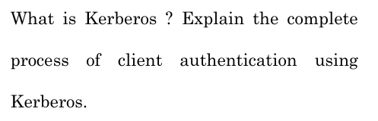
Ch Kerberos ek system hai jo computer network mein safe authentication karta hai.
Iska matlab hai ki client (user) aur server (service) ek dusre ko pehchan sakte hain
bina kisi hacker ke beech mein interfere kiye.
Kerberos ka process simple shabdon mein:
- Login Request:
  - Client apne username ke saath Authentication Server (AS) ko request bhejta hai.
  - Password directly nahi bheja jata, sirf username bheja jata hai.
- Authentication Server Response:
  - AS client ka password (stored hashed password) check karta hai. Agar sab theek hai, toh AS client ko do cheezein bhejta hai:
    - TGT (Ticket Granting Ticket): Jo ek encrypted ticket hai.
    - Session Key: Ek temporary key jo password se secure hoti hai.
- Session Key Use karna:
  - Client apni session key ko password se decrypt karta hai.
  - Ab client ke paas ek key hai jo uski identity ko prove kar sakti hai.
- Service ke liye Request:
  - Client Ticket Granting Service (TGS) ko TGT aur apna encrypted timestamp bhejta hai.
  - Ye request batata hai ki client kis service ko use karna chahta hai.
- Service Ticket milna:
  - TGS client ki request check karta hai aur ek Service Ticket bhejta hai.
  - Ye ticket service ke secret key se secure hota hai.
- Service ko Access karna:
  - Client apna Service Ticket aur timestamp service ko bhejta hai.
  - Service check karti hai ki ticket valid hai ya nahi.
- Secure Connection:
  - Agar sab kuch sahi hai, toh service aur client ek secure communication start karte hain jo session key ka use karta hai.
Is tarah, Kerberos ensure karta hai ki sirf valid users aur services ek dusre ke saath kaam kar sakein.

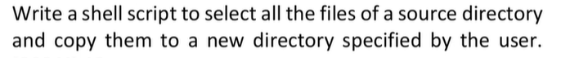
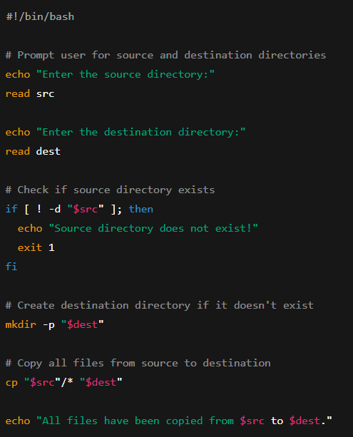

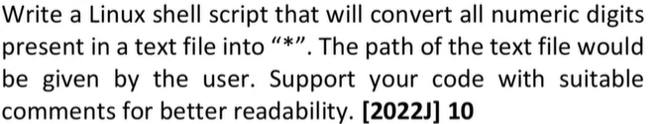
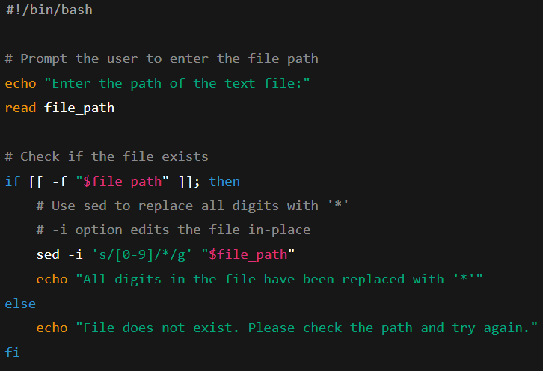

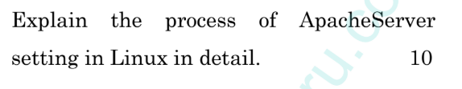
C Apache Server ko Linux par set up karne ka detailed process yeh hai:
Step 1: System Update karo
Sabse pehle apne Linux system ko update karo:
sudo apt update && sudo apt upgrade -y
Step 2: Apache Install karo
Step 2: Apache Install karo
Apache install karne ke liye yeh command run karo:
- Ubuntu/Debian ke liye:
sudo apt install apache2 -y
Step 3: Apache Start aur Enable karo
Apache ko start karo aur ensure karo ki yeh system start hote hi chalne lage:
Ubuntu/Debian ke liye:
sudo systemctl start apache2
- sudo systemctl enable apache2
Step 4: Browser mein Check karo
Browser open karo aur apne server ka IP address daalo:
http://<server-ip>
Agar Apache ka welcome page dikhe, to sab sahi hai.
Step 5: Firewall Allow karo
Agar firewall enabled hai, to Apache ko allow karo:
Ubuntu/Debian ke liye:
sudo ufw allow 'Apache'
- sudo ufw enable
Step 6: Apni Website Add karo
- Website files /var/www/html folder mein rakho.
- Folder permissions sahi karo:
sudo chown -R www-data:www-data /var/www/html
Step 7: Restart Apache
Changes save karne ke baad Apache ko restart karo:
sudo systemctl restart apache2
Step 8: (Optional) HTTPS Enable karo
Secure website ke liye SSL setup karna ho to Let's Encrypt ka use karo:
sudo apt install certbot python3-certbot-apache
sudo certbot --apache
Ab aapka Apache server ready hai aur website host karne ke liye tayaar hai! 😊


Ch Windows NT Registry Ke Main Parts
Registry me alag-alag sections hote hain, jinko hives kaha jata hai. Ye important hives hain:
- HKEY_LOCAL_MACHINE (HKLM): Puri system ki settings store karta hai.
- HKEY_CURRENT_USER (HKCU): Jo user login kiya hai uski personal settings rakhta hai.
- HKEY_CLASSES_ROOT (HKCR): Files aur software applications ke relations manage karta hai.
- HKEY_USERS (HKU): Sabhi users ki profiles ka data rakhta hai.
- HKEY_CURRENT_CONFIG (HKCC): Current system hardware ki information store karta hai.
Registry me keys aur values hoti hain, jo settings ko organize aur define karti hain.
Registry Ko Safe Kaise Rakhein?
Registry me important system settings hoti hain, isliye usko secure karna zaroori hai
- Unauthorized Users Ko Access Mat Dijiye
  - Sirf administrators ko registry me changes karne ka permission hona chahiye.
  - regedit.exe se registry ke permissions set karein.
- Group Policy Ka Use Karein
  - gpedit.msc open karein aur unnecessary registry access ko block karein.
- Regular Backup Banaayein
  - Agar kuch galat ho jaye to restore kar sakein.
  - regedit me jaake "Export" option ka use karein ya reg save command chalayein.
- Antivirus aur Security Software Lagayein
  - Windows Defender ya doosre antivirus tools use karein jo registry ko malware se bachayen.
- Remote Registry Access Band Karein
  - services.msc open karein aur "Remote Registry" service ko disable kar dein.
Registry Ke Changes Ko Kaise Check Karein? (Auditing)
Registry me hone wale changes ko track karna zaroori hai, taaki pata chale ki koi unauthorized modification toh nahi hui.
- Audit Policy Enable Karein
  - gpedit.msc me jaake "Audit Registry" option enable karein.
- Event Viewer Me Logs Dekhein
  - eventvwr.msc open karein aur Security Logs → Event ID 4657 check karein.
- PowerShell Ka Use Karein
  - Command prompt me yeh command likhein taaki pata chale ki koi changes hue hain ya nahi:
powershell
Get-EventLog -LogName Security | Where-Object { $_.EventID -eq 4657 }

